**Personal Blog on IBM Cloud Static Web Apps**

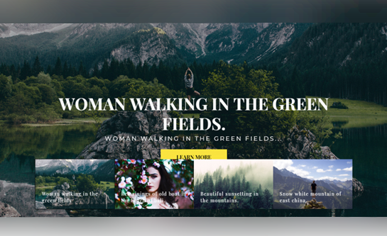

**Introduction:**

To convert your personal blog design into an innovative travel blog hosted on IBM Cloud Static Web Apps, you can take the following steps

1.Create Engaging Travel Content:

Focus on creating content related to travel experiences, destination guides, travel tips, and personal travel stories. Make your blog a valuable resource for fellow traveler.

2.Interactive Maps:

Incorporate interactive maps to showcase your travel routes and highlight key destinations. This can provide readers with a visual journey of your adventures.

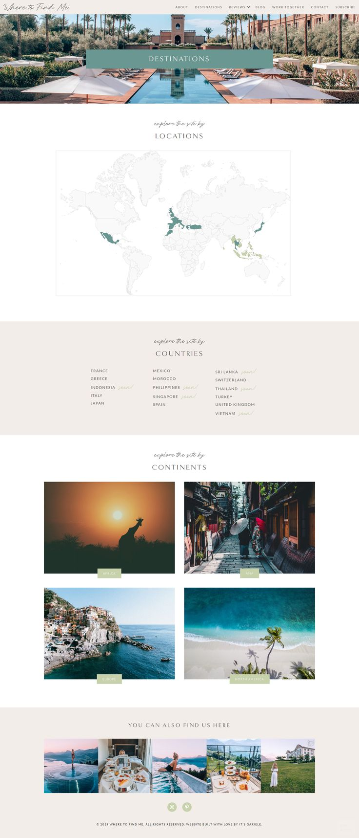

3.Travel Photography and Videos:

Include high-quality travel photos and videos in your blog posts to immerse your audience in your travel experiences. Share your visual stories.

4.Travel Resources and Tools:

Offer practical resources like packing checklists, visa guides, and travel insurance tips to assist your readers in planning their trips.

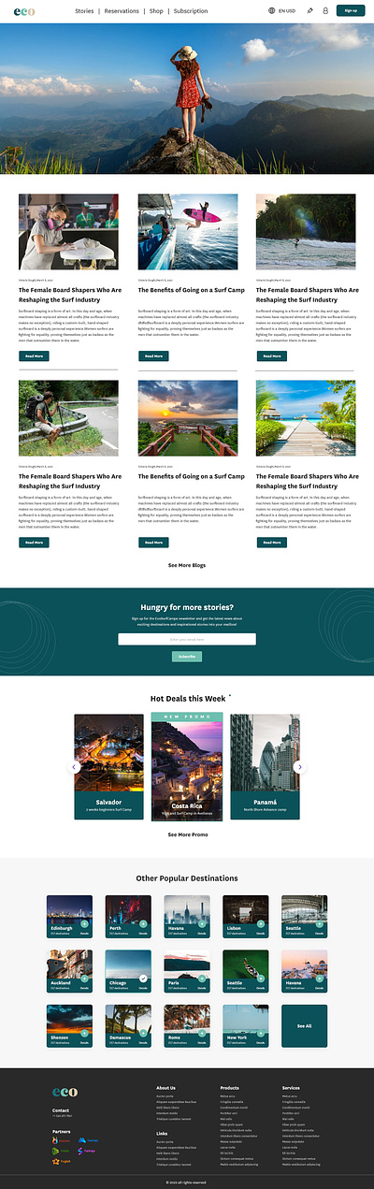

6.Travel Reviews and Recommendations:

Share honest reviews of hotels, restaurants, and attractions you've visited. Provide recommendations based on your personal experiences.

7.Social Media Integration:

Integrate social media sharing buttons and encourage readers to follow your travel adventures on platforms like Instagram, YouTube, and Twitter.

8.Language and Translation Options:

Consider adding language options or translation features to reach a global audience.

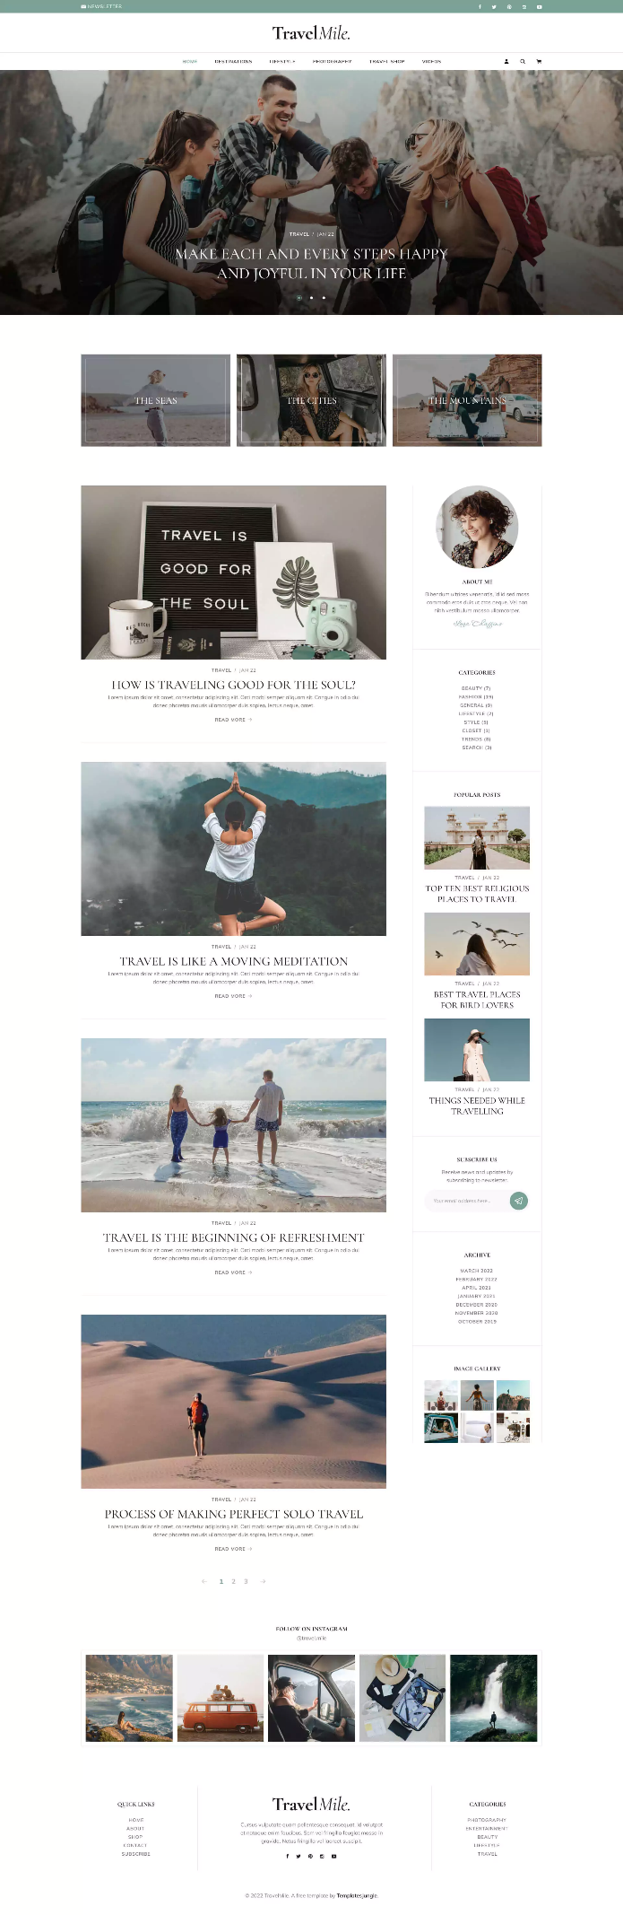

Welcome to My Travel Blog!

Here, I'll be sharing the stories woven into the landscapes I've explored, the cultures I've encountered, and the incredible people I've met along the way.

Embarking on Adventures:

Pack your virtual bags as we traverse through enchanting cities, get lost in the beauty of nature's wonders, and immerse ourselves in the rich tapestry of diverse cultures. Each destination is not just a pin on the map but a chapter in a novel of exploration and self-discovery.

Beyond the Postcards:

This blog is more than just picturesque landscapes and iconic landmarks. It's an exploration of the authentic, the unexpected, and the extraordinary. Get ready for insights into local life, hidden gems, and the moments that transform a journey into a profound experience.

Here, some source code:

Html code:

<!DOCTYPE html>

<html lang="en">

<head>

<meta charset="UTF-8">

<meta name="viewport" content="width=device-width, initial-scale=1.0">

<link rel="stylesheet" href="travel.css">

<title>Travel Blog</title>

</head>

<body>

<header>

<div class="navbar">

<ul>

<li><img src="images/Untitled (2) (2) (1) (1).png"></li>

<li><a href="#">Home</a></li>

<li><a href="#">Destinations</a></li>

<li><a href="#">Blog</a></li>

<li><a href="#">Contact</a></li>

</ul>

</div>

</header>

<br>

<br>

<br>

<main>

<section class="image-section">

<div class="image-overlay">

<img src="images/WhatsApp Image 2023-10-26 at 9.52.34 AM.jpeg" alt="my image" width="75%" height="50%">

<h1>WELCOME TO TRAVEL BLOG</h1>

<p>Indie traveller is all about travelling adventurously around the world</p>

<p>No sponsored trips just real travel trips</p>

<a href="index.html" class="custom-button">Learn More</a>

</div>

</section>

</main>

<br>

<br>

<br>

<br>

<br>

<footer>

<p>&copy; 2023 My Travel Blog</p>

</footer>

</body>

</html>

Css code:

body {

font-family: Arial, sans-serif;

margin: 0;

padding: 0;

background-color: #4CAF50; /* Lush Green */

color: #333;

background-color: #A3746C;

background-size: cover;

background-repeat: no-repeat;

background-attachment: fixed;

}

header {

background-color:black;

color: #333;

padding: 10px 0;

text-align: center;

margin-bottom: 20px;

}

.img{

width: 25%;

height: 25%;

}

/* styles.css */

.navbar {

background-color: black;

overflow: hidden;

}

.navbar ul {

list-style-type: none;

margin: 0;

padding: 0;

text-align: center;

}

.navbar li {

display: inline;

margin: 0 20px; /* Spacing between navigation items */

}

.navbar a {

text-decoration: none;

color: #fff; /* Text color of navigation items */

font-weight: bold;

font-size: 18px;

transition: color 0.3s; /* Smooth color transition on hover */

}

.navbar a:hover {

color: #FFA500; /* Color when hovered over */

}

footer {

background-color: #333;

color: #fff;

text-align: center;

padding: 20px 0;

}

/* Your existing CSS styles ... */

.image-section {

text-align: center;

position: relative;

}

.image-text {

position: absolute;

color: #fff;

top: 50%; /* Vertically centered */

left: 50%; /* Horizontally centered */

transform: translate(-50%, -50%); /* Center both vertically and horizontally */

font-size: 24px;

background: rgba(0, 0, 0, 0.7); /* Background color for text */

padding: 10px 20px; /* Padding around text */

}

.image-section h1{

color: black;

}

.image-section p{

color:black

}

.custom-button {

display: inline-block;

padding: 10px 20px;

background-color: #e4e00d; /* Button background color */

color: #fff; /* Button text color */

text-decoration: none; /* Remove underline */

border: none;

border-radius: 5px;

font-size: 16px;

cursor: pointer;

transition: background-color 0.3s;

}

.custom-button:hover {

background-color: #010305; /* Change color on hover */

}



Conclusion:

By implementing these strategies, you can transform your blog into an innovative travel platform that inspires and informs fellow travelerwhile leveraging the capabilities of IBM Cloud Static Web Apps for hosting and reliability.